**Create an Azure App Service Web App**

Steps:

1. Log into your Azure portal using the **Email** and **password** provided for you to the right of these tasks.
2. Click the **Create a resource** button (preceded by a large plus sign), then in the **Search services and marketplace** field, type in Web App and press enter. Find the result for **Web App** and click **Create > Web App**.

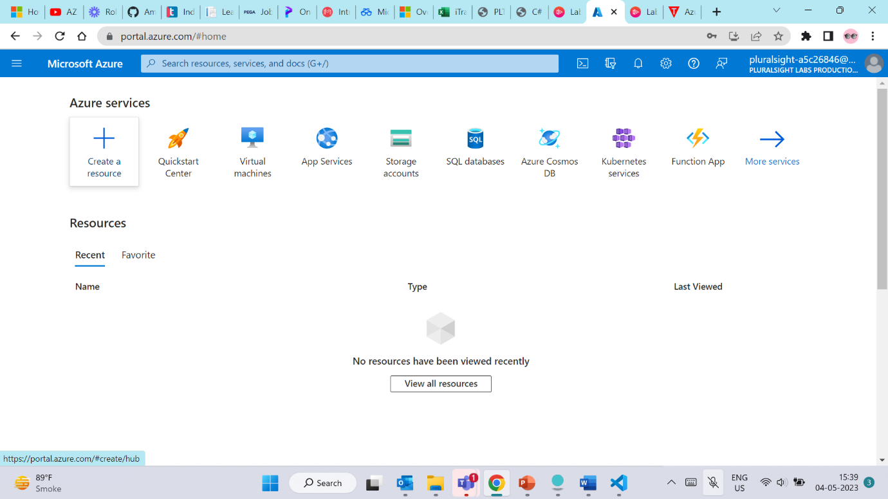

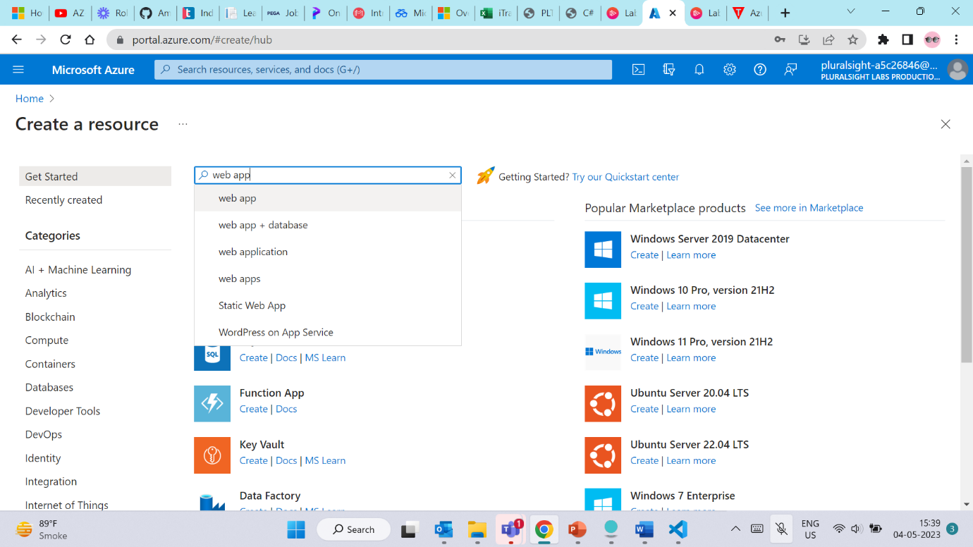

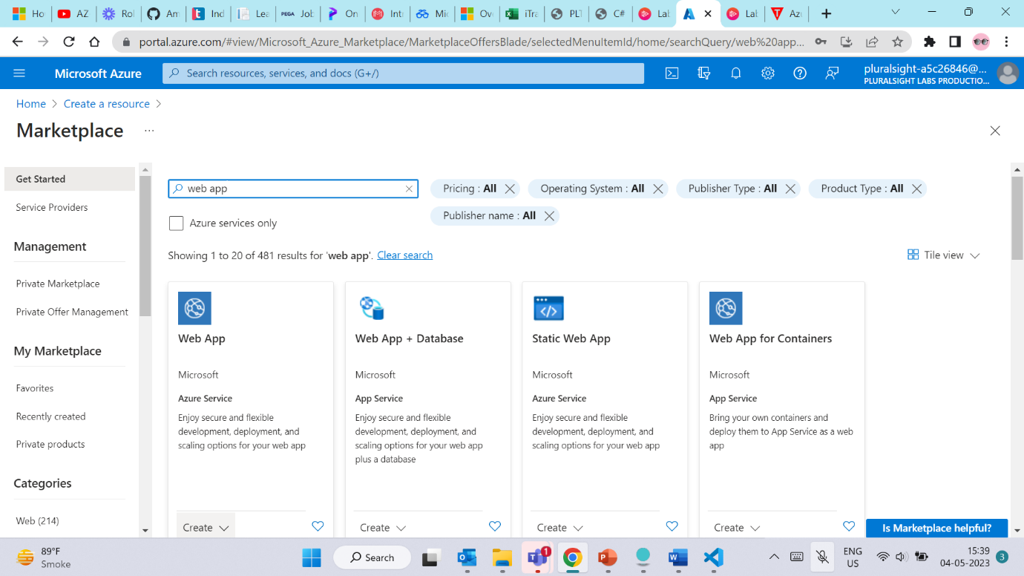

Note: It's is just **Web App**, NOT Web App Bot, and NOT Static Web App, for example

1. Fill in the following sections of the **Basics** tab:

Under **Project Details**:

* + Select the pre-created **pluralsight-resource-group**.

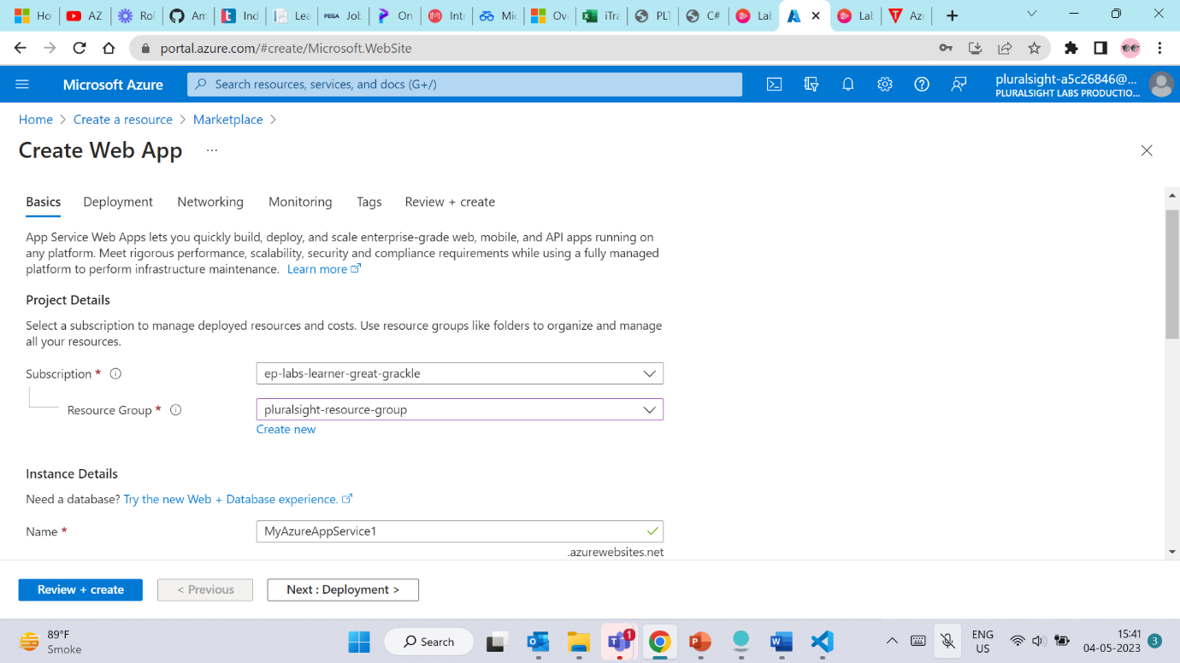

1. Under **Instance Details**:
   * Enter a **Name** for your Web App. This name must be unique within Azure. If you see **The app name is not available**, add more random digits or letters to the end of the name and try again.
   * Leave Publish set to Code.
   * Set **Runtime stack** to **ASP.NET V4.8**.
   * The Operating System will automatically be locked to Windows.
   * Set your **Region** to **Central US** (if needed)

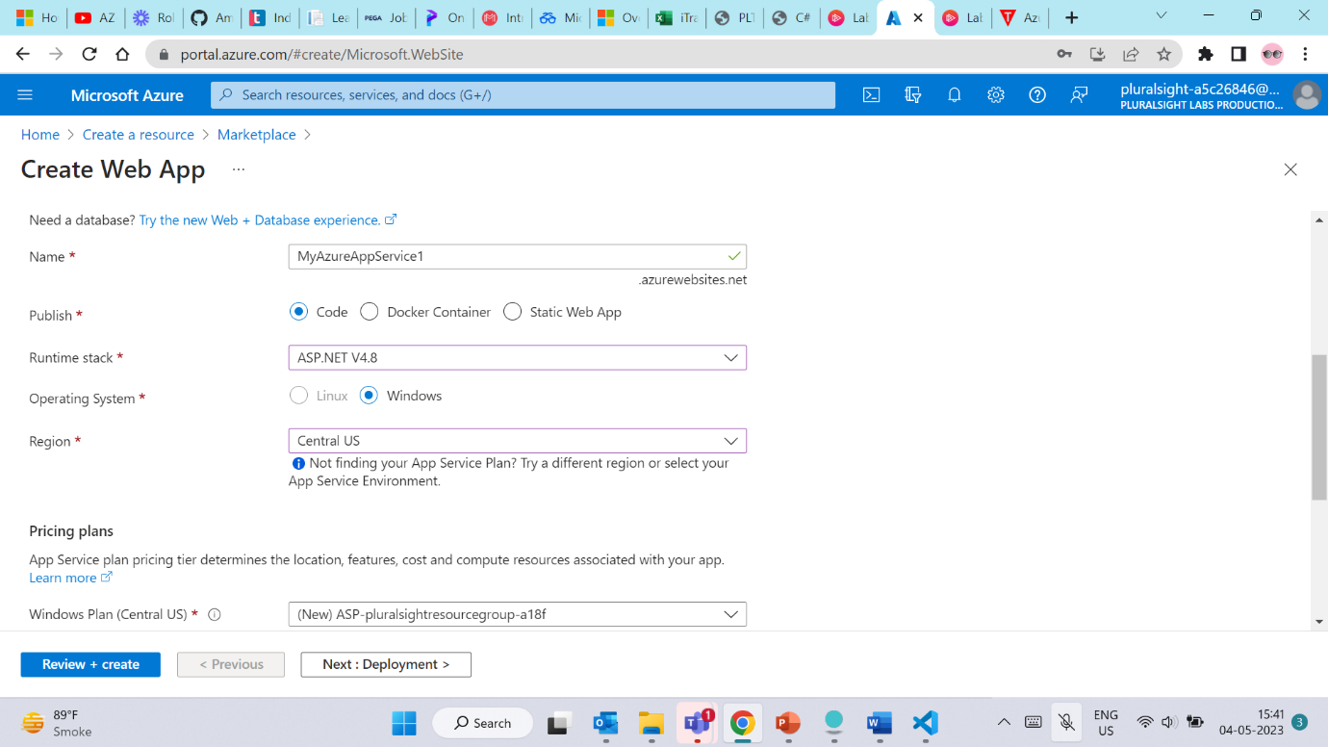

Under **App Service Plan**:

* + Leave Windows Planas is.
  + Change **Sku and size** to Standard S1by clicking **Change size**. In the **Spec Picker**, under the Production tab click on the **S1** panel, then click the **Apply** button.

For a production workload the Standard S1 plan is the recommended default choice. It includes features like autoscaling which will be required in one of the following challenges.

Once done, click the blue **Review + create** button at the bottom of the page.

1. In the **Review + create** tab, verify that all values are correct. Once done, click the blue **Create** button at the bottom of the page.

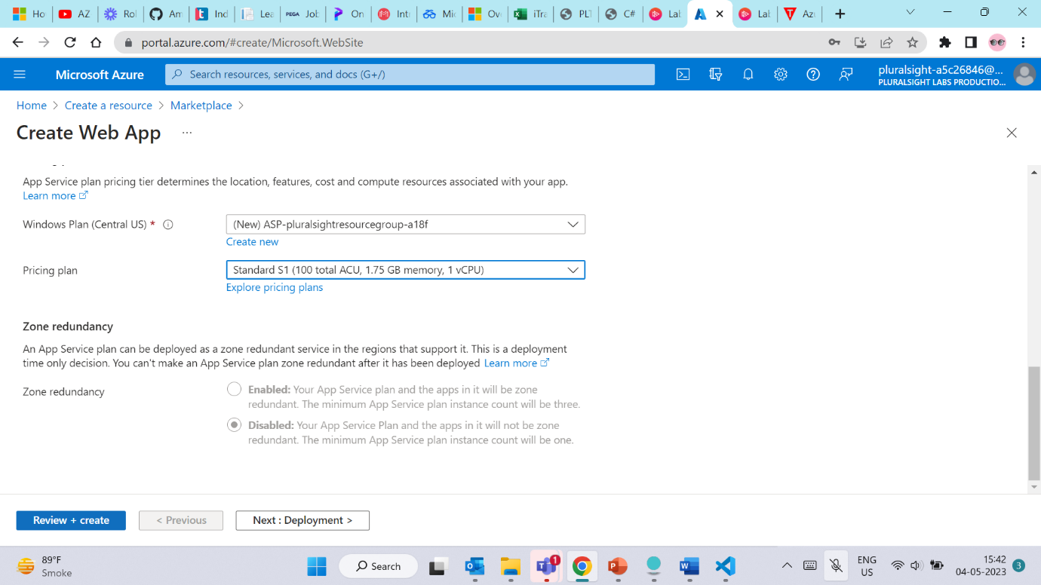

Your deployment is now in progress and within about one minute, Azure will have deployed the new resources.